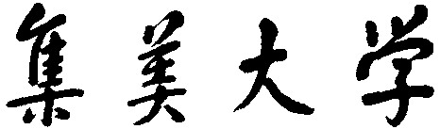

数据结构 课程设计

学 院 计算机工程学院 班 级 网络1811
姓 名 温海杰 学 号 201821123027
成 绩 指导老师 郑如滨

2019年 7 月 11 日

系统简介
模拟excel：
- 拥有正常显示数据功能；
- 能够实现上下翻页，并且能够无限向下翻页；
- 能够实现单关键字排序，多关键字排序；
- 能够保存信息；
- 有图形化界面；
- 排序提示（弥补按钮无动画效果）；
- 对排序进行计时，统计比较次数。

二、系统模块图

1.系统模块图：
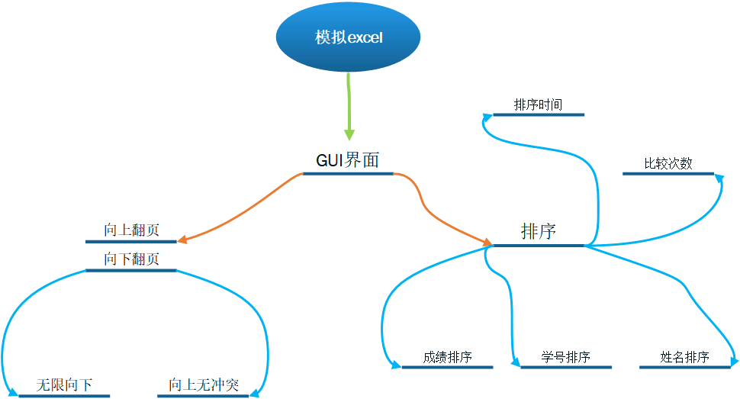

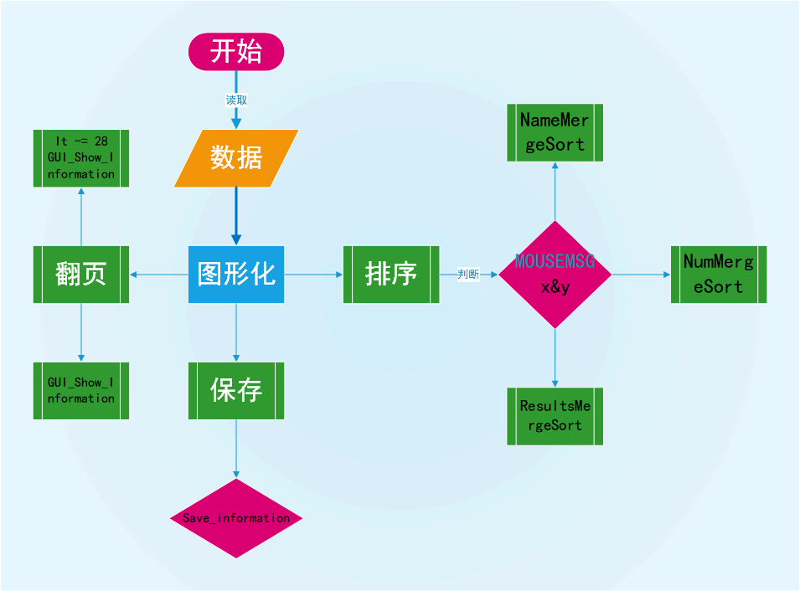
函数模块图

详细设计

数据结构
数据结构
- 使用了vector向量容器
- 使用归并排序
- 使用了string字符串处理数据

截图展示结构体定义
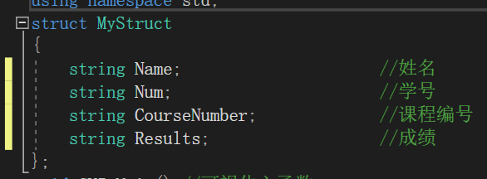

2.设计思路
- Funtion.cpp文件：排序的核心代码，主要是进行归并排序
- GUI.cpp文件：主要存放关于图形化的代码，功能有展示文件信息、鼠标控制等
- main.cpp文件：判断是否保存、调用GUI.cpp

运行结果截图
展示信息
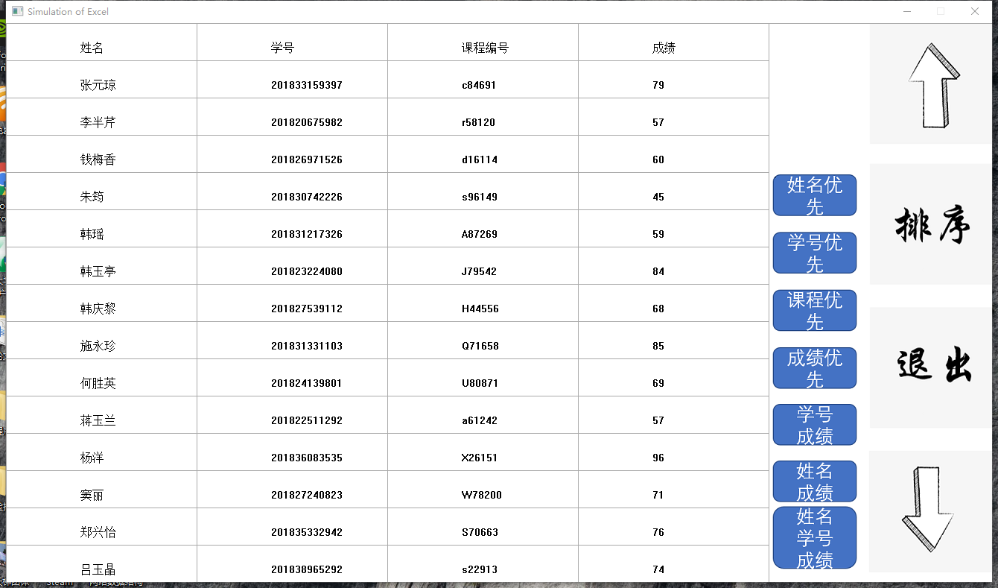

排序并展示比较次数及排序时间
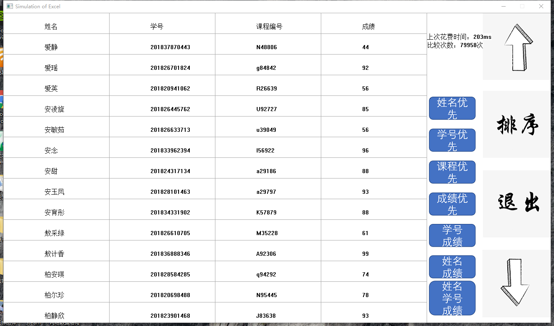

保存排序后的结果
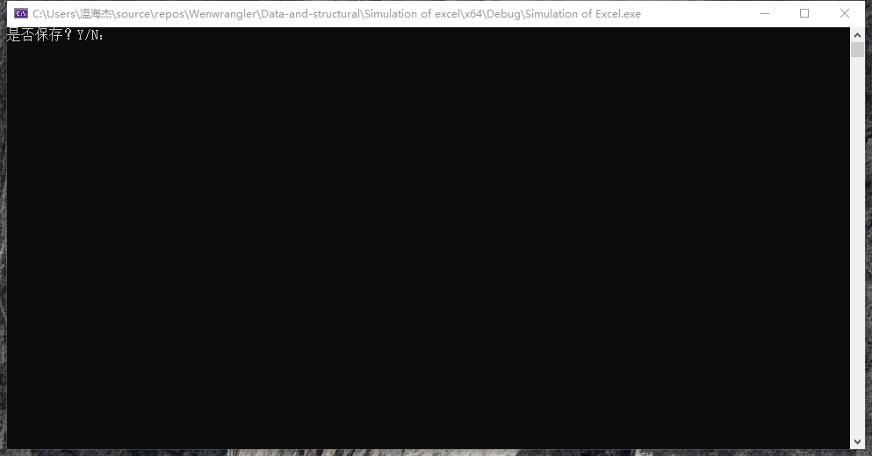

五、课程设计总结
- 本学期课程设计涉及的知识有：归并排序、二叉树、STL的vector，stable_sort，string 还有C语言的图形化插件 EasyX；
- 虽然只涉及到c/c++，但实际上能够学到很多其他的东西，比如用excel去生成一份很大的数据，例如我的文件是一份约7000条的表格，实现随机生成人名、学号、课程编号（字母+数字）、成绩；
- 发现string对于字符型数字处理不是很好，比如100与2进行比较应该是100>2，但是string的比较结果是2>100，在使用的时候需要考虑一下，或者用sprintf_s（sprintf）把字符串类型转换为int/double/long long类型；
- 调用Windows.h实现了Beep蜂鸣声和
DWORD StartTime, EndTime;
StartTime = GetTickCount();//计时开始
NameMergeSort(M, MS, 0, i - 1, idx); EndTime = GetTickCount();//计时结束
Clock_Number = EndTime - StartTime;
测出毫秒级的运行时间
- 或许学习EasyX算也一次计算机图形学入门？？？

六、程序清单（此块不要打印，电子版提交课堂派）

1.头文件.h
#pragma once
#include<conio.h>
#include<graphics.h>
#include<string.h>
#include<iostream>
#include<fstream>
#include<vector>
#include<algorithm>
#include<Windows.h>
#include <stdlib.h>
#include <cstdio>
using namespace std;
struct MyStruct
{
string Name; //姓名
string Num; //学号
string CourseNumber; //课程编号
string Results; //成绩
};
void GUI_Main();//可视化主函数
void GUI_Show_Information();//展示文本信息
void MySort();

void NameMergeSort(MyStruct sourceArr[], MyStruct tempArr[], int startIndex, int endIndex,int &idx);
void NameMerge(MyStruct sourceArr[], MyStruct tempArr[], int startIndex, int midIndex, int endIndex, int& idx);//姓名

void NumMergeSort(MyStruct sourceArr[], MyStruct tempArr[], int startIndex, int endIndex, int& idx);
void NumMerge(MyStruct sourceArr[], MyStruct tempArr[], int startIndex, int midIndex, int endIndex, int& idx);//学号

void CourseNumberMergeSort(MyStruct sourceArr[], MyStruct tempArr[], int startIndex, int endIndex, int& idx);
void CourseNumbernameMerge(MyStruct sourceArr[], MyStruct tempArr[], int startIndex, int midIndex, int endIndex, int& idx);//课程

void ResultsMergeSort(MyStruct sourceArr[], MyStruct tempArr[], int startIndex, int endIndex, int& idx);
void ResultsMerge(MyStruct sourceArr[], MyStruct tempArr[], int startIndex, int midIndex, int endIndex, int& idx);//成绩

void Name_ResultsMergeSort(MyStruct sourceArr[], MyStruct tempArr[], int startIndex, int endIndex, int& idx);
void Name_ResultsMerge(MyStruct sourceArr[], MyStruct tempArr[], int startIndex, int midIndex, int endIndex, int& idx);//姓名+成绩

void Num_ResultsMergeSort(MyStruct sourceArr[], MyStruct tempArr[], int startIndex, int endIndex, int& idx);
void Num_ResultsMerge(MyStruct sourceArr[], MyStruct tempArr[], int startIndex, int midIndex, int endIndex, int& idx);//学号+成绩

void Name_Num_ResultsMergeSort(MyStruct sourceArr[], MyStruct tempArr[], int startIndex, int endIndex, int& idx);
void Name_Num_ResultsMerge(MyStruct sourceArr[], MyStruct tempArr[], int startIndex, int midIndex, int endIndex, int& idx);//姓名+学号+成绩

void Save_information();

2.主控源程序文件 main.c
#include"head.h"
using namespace std;
int main() {
GUI_Main();
cout << "是否保存？Y/N：" << endl;
char prompt;
cin >> prompt;
if (prompt == 'Y'|| prompt == 'y') {
Save_information();
}
return 0;
}

3.各个模块.c文件
GUI.cpp
#include"head.h"
IMAGE t1;
vector<MyStruct> Data;
vector<MyStruct>::iterator it;
MyStruct Temp_Struct;
int x = 100, y = 25;
void GUI_Main() {
initgraph(1024 + 300, 750, SHOWCONSOLE);//初始化窗口
loadimage(&t1, _T("timg.png"));//读取图片
setlinecolor(LIGHTGRAY);
ifstream input("excel.txt");
if (input.fail()) {
cout << "文件打开失败！";
return;
}
while (!input.eof()) {
input >> Temp_Struct.Name >> Temp_Struct.Num >> Temp_Struct.CourseNumber >> Temp_Struct.Results;
Data.push_back(Temp_Struct);
}
it = Data.begin();
GUI_Show_Information();
while (1) {
MOUSEMSG Mouse_Event;
Mouse_Event = GetMouseMsg();
switch (Mouse_Event.uMsg){
case WM_LBUTTONDOWN:
if (Mouse_Event.x >= 1160 && Mouse_Event.x <= 1324 && Mouse_Event.y >= 585 && Mouse_Event.y <= 750) {//向下翻页 √
cleardevice();
GUI_Show_Information();
}
else if (Mouse_Event.x >= 1160 && Mouse_Event.x <= 1324 && Mouse_Event.y >= 388 && Mouse_Event.y <= 553) {//退出 √
closegraph();
return;
}
else if (Mouse_Event.x >= 1160 && Mouse_Event.x <= 1324 && Mouse_Event.y >= 192 && Mouse_Event.y <= 357) {//排序，点击排序后再点击各类排序
MySort();
}
else if (Mouse_Event.x >= 1160 && Mouse_Event.x <= 1324 && Mouse_Event.y >= 0 && Mouse_Event.y <= 164) {//向上翻页 √
for (int i = 0; i < 28 && it != Data.begin(); i++) {
it--;
}
cleardevice();
GUI_Show_Information();
}
break;
}
//FlushMouseMsgBuffer();
}
return;
}
void GUI_Show_Information() { //展示信息
setfillstyle(BS_DIBPATTERN, NULL, &t1);
setbkcolor(WHITE);
fillrectangle(1024, 0, 1324, 750);
for (int i = 1; i < 5; i++) {
fillrectangle(256 * i - 256, 0, 256 * i, 50 );
settextcolor(BLACK);
switch (i) {
case 1:
outtextxy(x + (i * 256 - 256), y , "姓名");
break;
case 2:
outtextxy(x + (i * 256 - 256), y , "学号");
break;
case 3:
outtextxy(x + (i * 256 - 256), y , "课程编号");
break;
case 4:
outtextxy(x + (i * 256 - 256), y , "成绩");
break;
}
}
for (int j = 2; j <= 15; j++) {
if (it != Data.end()) {
Temp_Struct = *it;
it++;
}
else {
Temp_Struct.CourseNumber = " ";
Temp_Struct.Name = " ";
Temp_Struct.Num = " ";
Temp_Struct.Results = " ";
}
for (int i = 1; i < 5; i++) {
fillrectangle(256 * i - 256, j * 50 - 50, 256 * i, 50 * j);
setfillcolor(WHITE);
//setlinecolor(LIGHTGRAY);
//settextcolor(BLACK);
switch (i) {
case 1:
outtextxy(x + (i * 256 - 256), y + (j * 50 - 50), Temp_Struct.Name.c_str());
break;
case 2:
outtextxy(x + (i * 256 - 256), y + (j * 50 - 50), Temp_Struct.Num.c_str());
break;
case 3:
outtextxy(x + (i * 256 - 256), y + (j * 50 - 50), Temp_Struct.CourseNumber.c_str());
break;
case 4:
outtextxy(x + (i * 256 - 256), y + (j * 50 - 50), Temp_Struct.Results.c_str());
break;
}
}
}
}
MyStruct M[10000], MS[10000];
void MySort() {
int Clock_Number;
MOUSEMSG Mouse_Temp;
int i = 0;
for (it = Data.begin(); it != Data.end(); it++) {
M[i] = *it;
i++;
}
DWORD StartTime, EndTime;
int idx = 0;
while (1) {
Mouse_Temp = GetMouseMsg();
switch (Mouse_Temp.uMsg){
case WM_LBUTTONDOWN:
if (Mouse_Temp.x >= 1032 && Mouse_Temp.x <= 1140) {
if (Mouse_Temp.y >= 206 && Mouse_Temp.y <= 257) {//姓名优先
StartTime = GetTickCount();//计时开始
NameMergeSort(M, MS, 0, i - 1, idx);
EndTime = GetTickCount();//计时结束
goto out;
}
else if (Mouse_Temp.y >= 283 && Mouse_Temp.y <= 335) {//学号优先
StartTime = GetTickCount();//计时开始
NumMergeSort(M, MS, 0, i - 1, idx);
EndTime = GetTickCount();//计时结束
goto out;
}
else if (Mouse_Temp.y >= 358 && Mouse_Temp.y <= 412) {//课程编号优先
StartTime = GetTickCount();//计时开始
CourseNumberMergeSort(M, MS, 0, i - 1, idx);
EndTime = GetTickCount();//计时结束
goto out;
}
else if (Mouse_Temp.y >= 435 && Mouse_Temp.y <= 490) {//成绩优先
StartTime = GetTickCount();//计时开始
ResultsMergeSort(M, MS, 0, i - 1, idx);
EndTime = GetTickCount();//计时结束
goto out;
}
else if (Mouse_Temp.y >= 510 && Mouse_Temp.y <= 566) {//学号+成绩优先
StartTime = GetTickCount();//计时开始
Num_ResultsMergeSort(M, MS, 0, i - 1, idx);
EndTime = GetTickCount();//计时结束
goto out;
}
else if (Mouse_Temp.y >= 587 && Mouse_Temp.y <= 642) {//姓名+成绩优先
StartTime = GetTickCount();//计时开始
Name_ResultsMergeSort(M, MS, 0, i - 1, idx);
EndTime = GetTickCount();//计时结束
goto out;
}
else if (Mouse_Temp.y >= 649 && Mouse_Temp.y <= 730) {//姓名+学号+成绩优先
StartTime = GetTickCount();//计时开始
Name_Num_ResultsMergeSort(M, MS, 0, i - 1, idx);
EndTime = GetTickCount();//计时结束
goto out;
}
}
break;
}

}
out:
Clock_Number = EndTime - StartTime;
Data.clear();
for (int j = 0; j < i; j++) {
Data.push_back(M[j]);
}
it = Data.begin();
GUI_Show_Information();
solidrectangle(1050, 1, 1130, 100);
settextcolor(BLACK);
string Clock = "上次花费时间：";
char T_clock[100];
sprintf_s(T_clock, "%d", Clock_Number);
Clock += T_clock;
Clock += "ms";
outtextxy(1025, 50, Clock.c_str());
char Compare_Number[10];
string CNumber="比较次数：";
sprintf_s(Compare_Number, "%d", idx);
CNumber += Compare_Number;
CNumber += "次";
outtextxy(1025, 70, CNumber.c_str());
Beep(494, 500);

}
void Save_information() {
ofstream output("excel.txt");
for (it = Data.begin(); it != Data.end(); it++) {
if ((it + 1) == Data.end()) {
output << (*it).Name << " " << (*it).Num << " " << (*it).CourseNumber << " " << (*it).Results;
break;
}
output << (*it).Name << " " << (*it).Num << " " << (*it).CourseNumber << " " << (*it).Results << endl;
}
output.close();
}

Funtion.cpp
#include"head.h"
//姓名排序
void NameMerge(MyStruct sourceArr[], MyStruct tempArr[], int startIndex, int midIndex, int endIndex,int &idx)//姓名
{
int i = startIndex, j = midIndex + 1, k = startIndex;
while (i != midIndex + 1 && j != endIndex + 1)
{
idx++;
if (sourceArr[i].Name > sourceArr[j].Name)
tempArr[k++] = sourceArr[j++];
else
tempArr[k++] = sourceArr[i++];

}
while (i != midIndex + 1)
tempArr[k++] = sourceArr[i++];
while (j != endIndex + 1)
tempArr[k++] = sourceArr[j++];
for (i = startIndex; i <= endIndex; i++)
sourceArr[i] = tempArr[i];
}
//内部使用递归
void NameMergeSort(MyStruct sourceArr[], MyStruct tempArr[], int startIndex, int endIndex, int& idx)
{
int midIndex;
if (startIndex < endIndex)
{
midIndex = startIndex + (endIndex - startIndex) / 2;//避免溢出int
NameMergeSort(sourceArr, tempArr, startIndex, midIndex, idx);
NameMergeSort(sourceArr, tempArr, midIndex + 1, endIndex, idx);
NameMerge(sourceArr, tempArr, startIndex, midIndex, endIndex, idx);
}

}

//学号排序
void NumMergeSort(MyStruct sourceArr[], MyStruct tempArr[], int startIndex, int endIndex, int& idx) {
int midIndex;
if (startIndex < endIndex)
{
midIndex = startIndex + (endIndex - startIndex) / 2;//避免溢出int
NumMergeSort(sourceArr, tempArr, startIndex, midIndex, idx);
NumMergeSort(sourceArr, tempArr, midIndex + 1, endIndex, idx);
NumMerge(sourceArr, tempArr, startIndex, midIndex, endIndex, idx);
}
}
void NumMerge(MyStruct sourceArr[], MyStruct tempArr[], int startIndex, int midIndex, int endIndex, int& idx) {
int i = startIndex, j = midIndex + 1, k = startIndex;
while (i != midIndex + 1 && j != endIndex + 1)
{
idx++;
if (sourceArr[i].Num > sourceArr[j].Num)
tempArr[k++] = sourceArr[j++];
else
tempArr[k++] = sourceArr[i++];

}
while (i != midIndex + 1)
tempArr[k++] = sourceArr[i++];
while (j != endIndex + 1)
tempArr[k++] = sourceArr[j++];
for (i = startIndex; i <= endIndex; i++)
sourceArr[i] = tempArr[i];
}

//课程
void CourseNumberMergeSort(MyStruct sourceArr[], MyStruct tempArr[], int startIndex, int endIndex, int& idx) {
int midIndex;
if (startIndex < endIndex)
{
midIndex = startIndex + (endIndex - startIndex) / 2;//避免溢出int
CourseNumberMergeSort(sourceArr, tempArr, startIndex, midIndex, idx);
CourseNumberMergeSort(sourceArr, tempArr, midIndex + 1, endIndex, idx);
CourseNumbernameMerge(sourceArr, tempArr, startIndex, midIndex, endIndex, idx);
}
}
void CourseNumbernameMerge(MyStruct sourceArr[], MyStruct tempArr[], int startIndex, int midIndex, int endIndex, int& idx) {
int i = startIndex, j = midIndex + 1, k = startIndex;
while (i != midIndex + 1 && j != endIndex + 1)
{
idx++;
if (sourceArr[i].CourseNumber > sourceArr[j].CourseNumber)
tempArr[k++] = sourceArr[j++];
else
tempArr[k++] = sourceArr[i++];

}
while (i != midIndex + 1)
tempArr[k++] = sourceArr[i++];
while (j != endIndex + 1)
tempArr[k++] = sourceArr[j++];
for (i = startIndex; i <= endIndex; i++)
sourceArr[i] = tempArr[i];
}

//成绩排序
void ResultsMergeSort(MyStruct sourceArr[], MyStruct tempArr[], int startIndex, int endIndex, int& idx) {
int midIndex;
if (startIndex < endIndex)
{
midIndex = startIndex + (endIndex - startIndex) / 2;//避免溢出int
ResultsMergeSort(sourceArr, tempArr, startIndex, midIndex, idx);
ResultsMergeSort(sourceArr, tempArr, midIndex + 1, endIndex, idx);
ResultsMerge(sourceArr, tempArr, startIndex, midIndex, endIndex, idx);
}
}
void ResultsMerge(MyStruct sourceArr[], MyStruct tempArr[], int startIndex, int midIndex, int endIndex, int& idx) {
int i = startIndex, j = midIndex + 1, k = startIndex;
while (i != midIndex + 1 && j != endIndex + 1)
{
idx++;
if (sourceArr[i].Results < sourceArr[j].Results)
tempArr[k++] = sourceArr[j++];
else
tempArr[k++] = sourceArr[i++];

}
while (i != midIndex + 1)
tempArr[k++] = sourceArr[i++];
while (j != endIndex + 1)
tempArr[k++] = sourceArr[j++];
for (i = startIndex; i <= endIndex; i++)
sourceArr[i] = tempArr[i];
}

//姓名+成绩
void Name_ResultsMergeSort(MyStruct sourceArr[], MyStruct tempArr[], int startIndex, int endIndex, int& idx) {
int midIndex;
if (startIndex < endIndex)
{
midIndex = startIndex + (endIndex - startIndex) / 2;//避免溢出int
Name_ResultsMergeSort(sourceArr, tempArr, startIndex, midIndex, idx);
Name_ResultsMergeSort(sourceArr, tempArr, midIndex + 1, endIndex, idx);
Name_ResultsMerge(sourceArr, tempArr, startIndex, midIndex, endIndex, idx);
}
}
void Name_ResultsMerge(MyStruct sourceArr[], MyStruct tempArr[], int startIndex, int midIndex, int endIndex, int& idx) {
int i = startIndex, j = midIndex + 1, k = startIndex;
while (i != midIndex + 1 && j != endIndex + 1)
{
idx++;
if (sourceArr[i].Results == sourceArr[j].Results) {
if (sourceArr[i].Name > sourceArr[j].Name) {
tempArr[k++] = sourceArr[j++];
}
else {
tempArr[k++] = sourceArr[i++];
}
}
else
{
if (sourceArr[i].Results < sourceArr[j].Results)
tempArr[k++] = sourceArr[j++];
else
tempArr[k++] = sourceArr[i++];
}
}
while (i != midIndex + 1)
tempArr[k++] = sourceArr[i++];
while (j != endIndex + 1)
tempArr[k++] = sourceArr[j++];
for (i = startIndex; i <= endIndex; i++)
sourceArr[i] = tempArr[i];
}

//成绩+学号
void Num_ResultsMergeSort(MyStruct sourceArr[], MyStruct tempArr[], int startIndex, int endIndex, int& idx) {
int midIndex;
if (startIndex < endIndex)
{
midIndex = startIndex + (endIndex - startIndex) / 2;//避免溢出int
Num_ResultsMergeSort(sourceArr, tempArr, startIndex, midIndex, idx);
Num_ResultsMergeSort(sourceArr, tempArr, midIndex + 1, endIndex, idx);
Num_ResultsMerge(sourceArr, tempArr, startIndex, midIndex, endIndex, idx);
}
}
void Num_ResultsMerge(MyStruct sourceArr[], MyStruct tempArr[], int startIndex, int midIndex, int endIndex, int& idx) {
int i = startIndex, j = midIndex + 1, k = startIndex;
while (i != midIndex + 1 && j != endIndex + 1)
{
idx++;
if (sourceArr[i].Results == sourceArr[j].Results) {
if (sourceArr[i].Num > sourceArr[j].Num) {
tempArr[k++] = sourceArr[j++];
}
else {
tempArr[k++] = sourceArr[i++];
}
}
else
{
if (sourceArr[i].Results < sourceArr[j].Results)
tempArr[k++] = sourceArr[j++];
else
tempArr[k++] = sourceArr[i++];
}
}
while (i != midIndex + 1)
tempArr[k++] = sourceArr[i++];
while (j != endIndex + 1)
tempArr[k++] = sourceArr[j++];
for (i = startIndex; i <= endIndex; i++)
sourceArr[i] = tempArr[i];
}

//姓名+学号+成绩
void Name_Num_ResultsMergeSort(MyStruct sourceArr[], MyStruct tempArr[], int startIndex, int endIndex, int& idx) {
int midIndex;
if (startIndex < endIndex)
{
midIndex = startIndex + (endIndex - startIndex) / 2;//避免溢出int
Name_Num_ResultsMergeSort(sourceArr, tempArr, startIndex, midIndex, idx);
Name_Num_ResultsMergeSort(sourceArr, tempArr, midIndex + 1, endIndex, idx);
Name_Num_ResultsMerge(sourceArr, tempArr, startIndex, midIndex, endIndex, idx);
}
}
void Name_Num_ResultsMerge(MyStruct sourceArr[], MyStruct tempArr[], int startIndex, int midIndex, int endIndex, int& idx) {
int i = startIndex, j = midIndex + 1, k = startIndex;
while (i != midIndex + 1 && j != endIndex + 1)
{
idx++;
if (sourceArr[i].Results == sourceArr[j].Results) {
if (sourceArr[i].Name == sourceArr[j].Name) {
if (sourceArr[i].Num > sourceArr[j].Num) {
tempArr[k++] = sourceArr[j++];
}
else {
tempArr[k++] = sourceArr[i++];
}
}
else if (sourceArr[i].Name > sourceArr[j].Name) {
tempArr[k++] = sourceArr[j++];
}
else {
tempArr[k++] = sourceArr[i++];
}
}
else if (sourceArr[i].Results < sourceArr[j].Results)
tempArr[k++] = sourceArr[j++];
else
tempArr[k++] = sourceArr[i++];

}
while (i != midIndex + 1)
tempArr[k++] = sourceArr[i++];
while (j != endIndex + 1)
tempArr[k++] = sourceArr[j++];
for (i = startIndex; i <= endIndex; i++)
sourceArr[i] = tempArr[i];
}

